**<Staff> Input new website**

**Use Case Diagram**

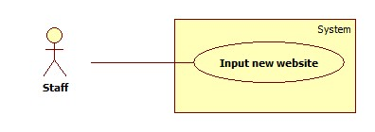

Figure 1 - <Staff> Input new website

**Use Case Specification**

|  |  |  |  |
| --- | --- | --- | --- |
| **USE CASE - <UC Number>** | | | |
| **Use Case No.** |  | **Use Case Version** | 1.0 |
| **Use Case Name** | Input new website | | |
| **Author** | Nguyen Le Hoang Thien | | |
| **Date** | 21/01/2016 | **Priority** | High |
| **Actor:**   * Staff.   **Summary:**   * This use case helps staff input new cooking website in order to set parser configuration or parse recipe.   **Goal:**   * Input new cooking website and load its resource to view.   **Triggers:**   * Staff sends Input new website command.   **Preconditions:**   * N/A   **Post Conditions:**   * **Success**: The resource of new website is loaded. * **Fail**: Show error messages.   **Main Success Scenario:**   |  |  |  | | --- | --- | --- | | **Step** | **Actor Action** | **System Response** | | 1 | Staff goes to Input new website view. | System shows view and requires information from staff:  **Website information**   * URL of new website: free text input, required, length [10,250] | | 2 | Staff inputs information |  | | 3 | Staff sends command to load the input website. | System connects to the inputted website, shows all resources of the website to view.  [Exception 1, 2] |   **Alternative Scenario: N/A**  **Exception**   |  |  |  | | --- | --- | --- | | **No** | **Actor Action** | **System Response** | | 1 | Staff sends Load new website command with invalid inputted data.   * The inputted URL is not long enough or long than 250 characters. | System will show error message: “The length of URL must be from 10 to 250. Please input again”. | | 2 | The system cannot connect to inputted website.   * The inputted URL is wrong. | System will show error message: “The website cannot be connected. Please check your inputted URL. It’s maybe incorrect”. |   **Relationships:** Set parser configuration, Parse manually.  **Business rules:**   * The input website will be showed in the staff’s view. | | | |

**<Staff> Set parser configuration**

**Use Case Diagram**

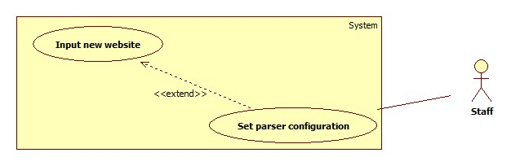

Figure 2 - <Staff> Input new website

**Use Case Specification**

|  |  |  |  |
| --- | --- | --- | --- |
| **USE CASE - <UC Number>** | | | |
| **Use Case No.** |  | **Use Case Version** | 1.0 |
| **Use Case Name** | Set parser configuration | | |
| **Author** | Nguyen Le Hoang Thien | | |
| **Date** | 21/01/2016 | **Priority** | High |
| **Actor:**   * Staff.   **Summary:**   * This use case allows staff to set configuration of inputted website for auto parsing resources.   **Goal:**   * Set configuration for each website for auto parsing.   **Triggers:**   * Staff sends Set configuration command.   **Preconditions:**   * Staff passes inputting new website stage. * The resource of website is loaded.   **Post Conditions:**   * **Success**:   + New configuration file is inserted to storage.   * **Fail**:   + Show error message. Storage is unchanged.  **Main Success Scenario:**   |  |  |  | | --- | --- | --- | | **Step** | **Actor Action** | **System Response** | | 1 | Staff goes to Set parser configuration view. | System loaded all resource of inputted website to view. | | 2 | Staff clicks each necessary element for recipe. | System gets XPath of clicked element and shows a pop-up contain XPath and data every element-click.  System shows notification when staff completes each element of recipe.  System storage XPath into temporary storage. | | 3 | Staff finishes clicking and sends “Preview” command. | System compares all of XPaths to get common XPath for each element.  [Exception 1]  System opens a new view and shows a table containing final data of recipe parsed from XPaths. | | 4 | Staff sends add new configuration command.  [Alternative 1]  [Alternative 2] | New parser configuration is added to system. |   **Alternative Scenario**   |  |  |  | | --- | --- | --- | | **No** | **Actor Action** | **System Response** | | 1 | Staff closes the preview view. | System closes the preview view. The data is unchanged. | | 2 | Staff sends reset command. | All gotten data are cleared. The preview view is closed. |   **Exception**   |  |  |  | | --- | --- | --- | | **No** | **Actor Action** | **System Response** | | 1 | System cannot get common XPath of each element. | System will show error message: “The system cannot recognize the common XPath of each element. Please try again”.  All the temporary data are cleared. |   **Relationships:** Input new website.  **Business rules:**   * Staff must click the elements in the order: Recipe name – Introduction – Recipe image – Material – Recipe step. * Which Recipe name, Introduction and Recipe image, staff just need click one time for each element. But with Material and Recipe, because they have more than one paragraph, staff must click 3 times for every needed element. Three times is the greatest of times for system can get XPath exactly. * When system cannot get common XPath of each element. Maybe this page has the strange XPath or the XPaths don’t have the same rule. In this case, staff should parse this recipe manually. | | | |

**<Staff> View logs**

**Use Case Diagram**

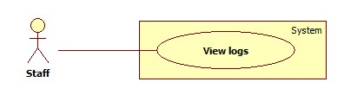

Figure 3 - <Staff> View logs

**Use Case Specification**

|  |  |  |  |
| --- | --- | --- | --- |
| **USE CASE - <UC Number>** | | | |
| **Use Case No.** |  | **Use Case Version** |  |
| **Use Case Name** | View logs | | |
| **Author** | Nguyen Le Hoang Thien | | |
| **Date** | 21/01/2016 | **Priority** | Normal |
| **Actor:**   * Staff   **Summary:**   * This use case allows staff view logs from systems.   **Goal:**   * Staff can view logs created by system.   **Triggers:**   * Staff sends view logs command.   **Preconditions:** N/A  **Post Conditions:**   * Success:   + System changes state of all logs to “read”.   * Fail:   + The logs with state “pending” don’t be changed to “read”.  **Main Success Scenario:**   |  |  |  | | --- | --- | --- | | **Step** | **Actor Action** | **System Response** | | 1 | Staff goes to View logs view. | System shows view.  System loads all logs with state “pending” to the table of view.  [Exception 1] | | 2 | Staff completes reading all logs and sends Complete command. | System changes all states of logs to “read”. |   **Alternative Scenario: N/A**  **Exception**   |  |  |  | | --- | --- | --- | | **No** | **Actor Action** | **System Response** | | 1 | System cannot connect to log file. | System will show error message: “The system cannot connect to log file. Please try again.” |   **Business rules**   * The new log is created with state “pending”. When it’s read, its state changes to “read”. | | | |

**<Staff> Parse manually**

**Use Case Diagram**

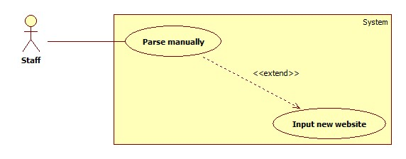

Figure 4 - <Staff> Parse manually

**Use Case Specification**

|  |  |  |  |
| --- | --- | --- | --- |
| **USE CASE - <UC Number>** | | | |
| **Use Case No.** |  | **Use Case Version** | 1.0 |
| **Use Case Name** | Parse manually | | |
| **Author** | Nguyen Le Hoang Thien | | |
| **Date** | 21/01/2016 | **Priority** | High |
| **Actor:**   * Staff.   **Summary:**   * This use case helps staff parse a new recipe manually.   **Goal:**   * Parse a new recipe to system’s storage from the inputted website.   **Triggers:**   * Staff sends Parse manually command.   **Preconditions:**   * Staff passes inputting new website stage. * The resource of website is loaded.   **Post Conditions:**   * **Success**: The new recipe is inserted to storage. * **Fail**: Show error messages. Storage is unchanged.   **Main Success Scenario:**   |  |  |  | | --- | --- | --- | | **Step** | **Actor Action** | **System Response** | | 1 | Staff goes to Parse manually view. | System loaded all resource of inputted website to view. | | 2 | Staff clicks each necessary element for recipe. | System gets XPath of clicked element and shows a pop-up contain XPath and data every element-click.  System storage XPath into temporary storage. | | 3 | Staff sends “Preview” command. | System opens a new view and shows a table containing final data.  [Exception 1] | | 4 | Staff sends Save command.  [Alternative 1]  [Alternative 2] | The data is inserted to the storage. |   **Alternative Scenario**   |  |  |  | | --- | --- | --- | | **No** | **Actor Action** | **System Response** | | 1 | Staff closes the preview view. | System closes the preview view. The data is unchanged. | | 2 | Staff sends reset command. | All gotten data are cleared. The preview window is closed. |   **Exception**   |  |  |  | | --- | --- | --- | | **No** | **Actor Action** | **System Response** | | 1 | System cannot parse information from one or some XPath. | System will show error message for each XPath that cannot be parsed: “This XPath cannot be parsed.” |   **Relationships:** Input new website.  **Business rules:**   * Staff must click the elements in the order: Recipe name – Introduction – Recipe image – Material – Recipe step. * When system show the table containing the information parsed, staff can edit this table. Staff can do that when there are some XPaths cannot be parsed. | | | |